**Instructions for Submitting Additional Proposals**

*Bidders are required to create additional accounts for any additional main proposals. Bidders have two options: 1) follow the below instructions to add their additional account(s), or 2) contact SRP via the Messaging Portal so SRP can set up the account on the bidder’s behalf.*

1. Navigate to the following [registration link](https://www.poweradvocate.com/compiled/supplier-registration/app/index.html?companyKey=qoKwE38eNC8%3D&locale=en_US)
2. Enter your email address when prompted

Wood Mackenzie will send a code to the email address provided

1. Enter the WoodMac code

This will direct you to your existing account page. Wood Mackenzie will list all accounts registered under your email. As an example, in the figure below, one company is already registered as “Ortiz” the given email address.

1. Select “Create New Account”

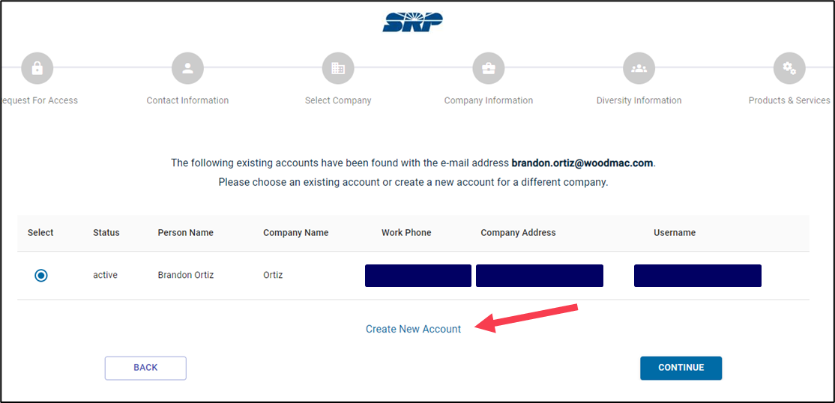

1. Enter your First Name, Last Name, Work Phone, Job Title, and Timezone and select “continue.”

On the next screen, you should see a drop-down box of companies to choose from.

If you do not see a list, type “XX” in the “select company” box to display a drop-down list.

Instead of selecting your existing company profile, select “Company “XX” not listed? Click to “add it”. Information boxes will appear below.

1. Enter the name of your project and requested information. The “Site Name” is the name of your proposed project, not the registered name. Select “Continue.”

1. Enter your company information in the fields requested and select “Continue.” Following the previous example, the company name would be Ortiz 1. Additional proposals would have the company names Ortiz 2, Ortiz 3, etc.

Continue answering all required information as requested at each screen.

1. Answer the diversity question (Y/N) and select “Continue.”
2. Select your company’s products/services and select “Continue.”
3. Create a username and password (different from your previous account passwords)

When finished registering your new account, notify SRP of your new account name by sending a message through the WoodMac tool (using your original account registered in the 2024 All Source RFP Event). State in your message the exact name of your new registered company (including spaces, case sensitivity, etc.)

SRP will search for your new company name and add you to the bid event.

If you have any questions, please contact Wood Mackenzie at 857-453-5800.